AIRERA
A Software Reference Architecture for Natural Language Processing Tools in Requirements Engineering

1. Introduction
Context and Motivation. Natural Language Processing tools are widely used to support Requirements Engineering tasks such as elicitation, classification, traceability, and validation [1]. Despite recurring functional similarities, existing NLP4RE tools are typically developed as monolithic, standalone systems. This practice leads to duplicated implementation effort, limited interoperability, poor comparability across tools, and low long-term maintainability [1, 2, 3].

Goal. The main goal of this initiative is to shift away from isolated, monolithic tools towards an ecosystem of interoperable and reusable modules, as exemplified in the figure below.

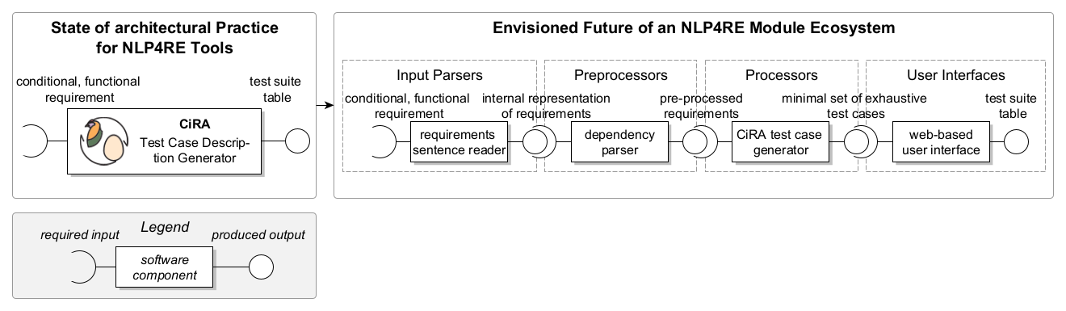
Figure 1. Envisioned shift of the NLP4RE tool landscape at the example of the tool CiRA [7]

Contribution. To achieve this, we present AIRERA, a Software Reference Architecture (SRA) for NLP4RE tools.

📒 A software reference architecture is an abstraction of domain-specific software architectures guiding and standardizing system design and development practices within that domain [6].

AIRERA captures common architectural structures, responsibilities, and interaction patterns observed across NLP4RE tools, while remaining independent of specific NLP technologies, tasks, or implementation choices.
Method. AIRERA is developed following the ProSA-RA methodology by Nakagawa et al. [4], based on (1) systematic analyses of NLP4RE tools and literature, (2) stakeholder input, and (3) architectural requirements abstracted from recurring system-level needs. The architecture is documented following the principles outlined by Clements et al. [5].

2. Software Reference Architecture
AIRERA is a Software Reference Architecture (SRA) documented from multiple architectural views, i.e., the documentation of the architecture from a specific viewpoint that highlights distinct elements and relationships of the system [5]. The three views presented below belong to one of two styles:

- Module style (2.1. Layered View): decomposition of software into its implementation units
- Component-and-connector style (2.2. Service-Oriented Architecture View and 2.3. Pipe-and-Filter View): runtime elements of the systems

Together, the views provide a holistic understanding of the architecture without prescribing a single implementation.

2.1. Layered View

📒 A layered view organizes software elements into hierarchical layers with well-defined responsibilities and dependency constraints. This view is particularly useful to reason about separation of concerns, change impact, and responsibility allocation.

Figure 1 illustrates the layered view of AIRERA, which structures NLP4RE tools into four layers: Presentation, Service, Data, and Cross-cutting.
- The Presentation Layer contains components responsible for interacting with users and external systems. The Output Producer consumes results from service modules and coordinates visualization, explanation, and export through the Explainability Manager and Export Manager.
- The Service Layer encapsulates the core processing logic. The Orchestrator assembles and executes a configurable pipeline composed of Input Consumers, Preprocessors, Processors, and Postprocessors to feed into Output Producers. The Processing Module abstraction defines a uniform execution interface across all pipeline steps.
- The Data Layer manages persistent artifacts. The Storage System preserves runtime artifacts such as inputs, intermediate results, outputs, and execution traces, while the Tool Metadata Repository stores static metadata including documentation, versions, dependencies, licenses, NLP technologies, and supported tasks.
- The Cross-cutting Layer contains the Logger, which captures execution data across all layers and ensures traceability, reproducibility, and recoverability.
In AIRERA, this layered decomposition explicitly separates user-facing concerns (Output Producer, Explainability Manager, Export Manager) from pipeline coordination and execution (Orchestrator and Processing Modules), and from artifact persistence and metadata management (Storage System and Tool Metadata Repository). By constraining dependencies to flow through well-defined interfaces across layers, AIRERA prevents direct coupling between presentation logic, NLP processing logic, and data management. This enables individual pipeline modules, visualization mechanisms, or storage backends to evolve, be replaced, or be reused across tools without impacting the remaining layers.
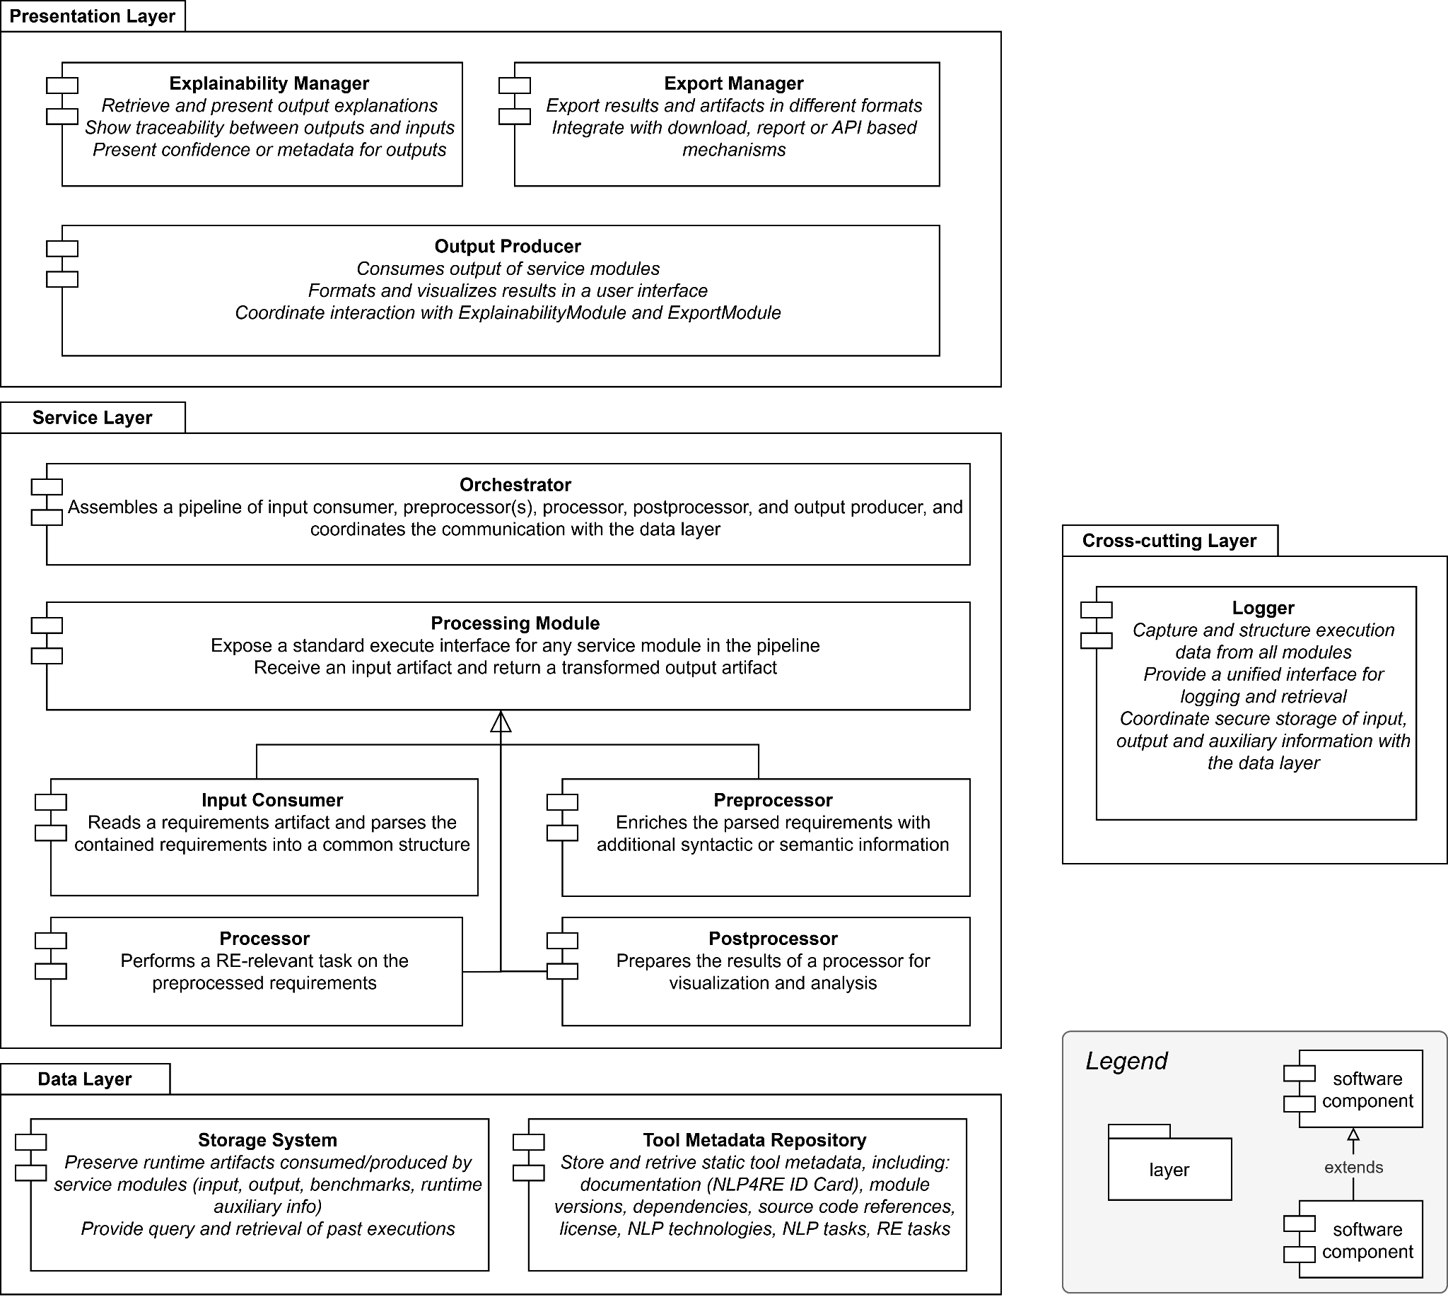
Figure 2. Layered View of AIRERA

2.2. Service-Oriented Architecture View

📒 A service-oriented architecture (SOA) view focuses on runtime components, their provided and required interfaces, and their interaction patterns. It supports reasoning about interoperability, substitutability, and runtime composition.

In AIRERA, core functionality is exposed through explicit service interfaces to enable loose coupling and interchangeability.
- The Orchestrator Service exposes interfaces to execute pipelines, access results, and retrieve execution metadata.
- The Output Producer Interface provides standardized access points for visualization, explanation, and export services.
- The Explainability Manager and Export Manager act as specialized services that consume outputs via the Output Producer interface.
- The Logger Service records execution events through a dedicated interface, decoupled from functional services.
- Data services such as the Storage System and Tool Metadata Repository expose access and persistence operations through well-defined interfaces.
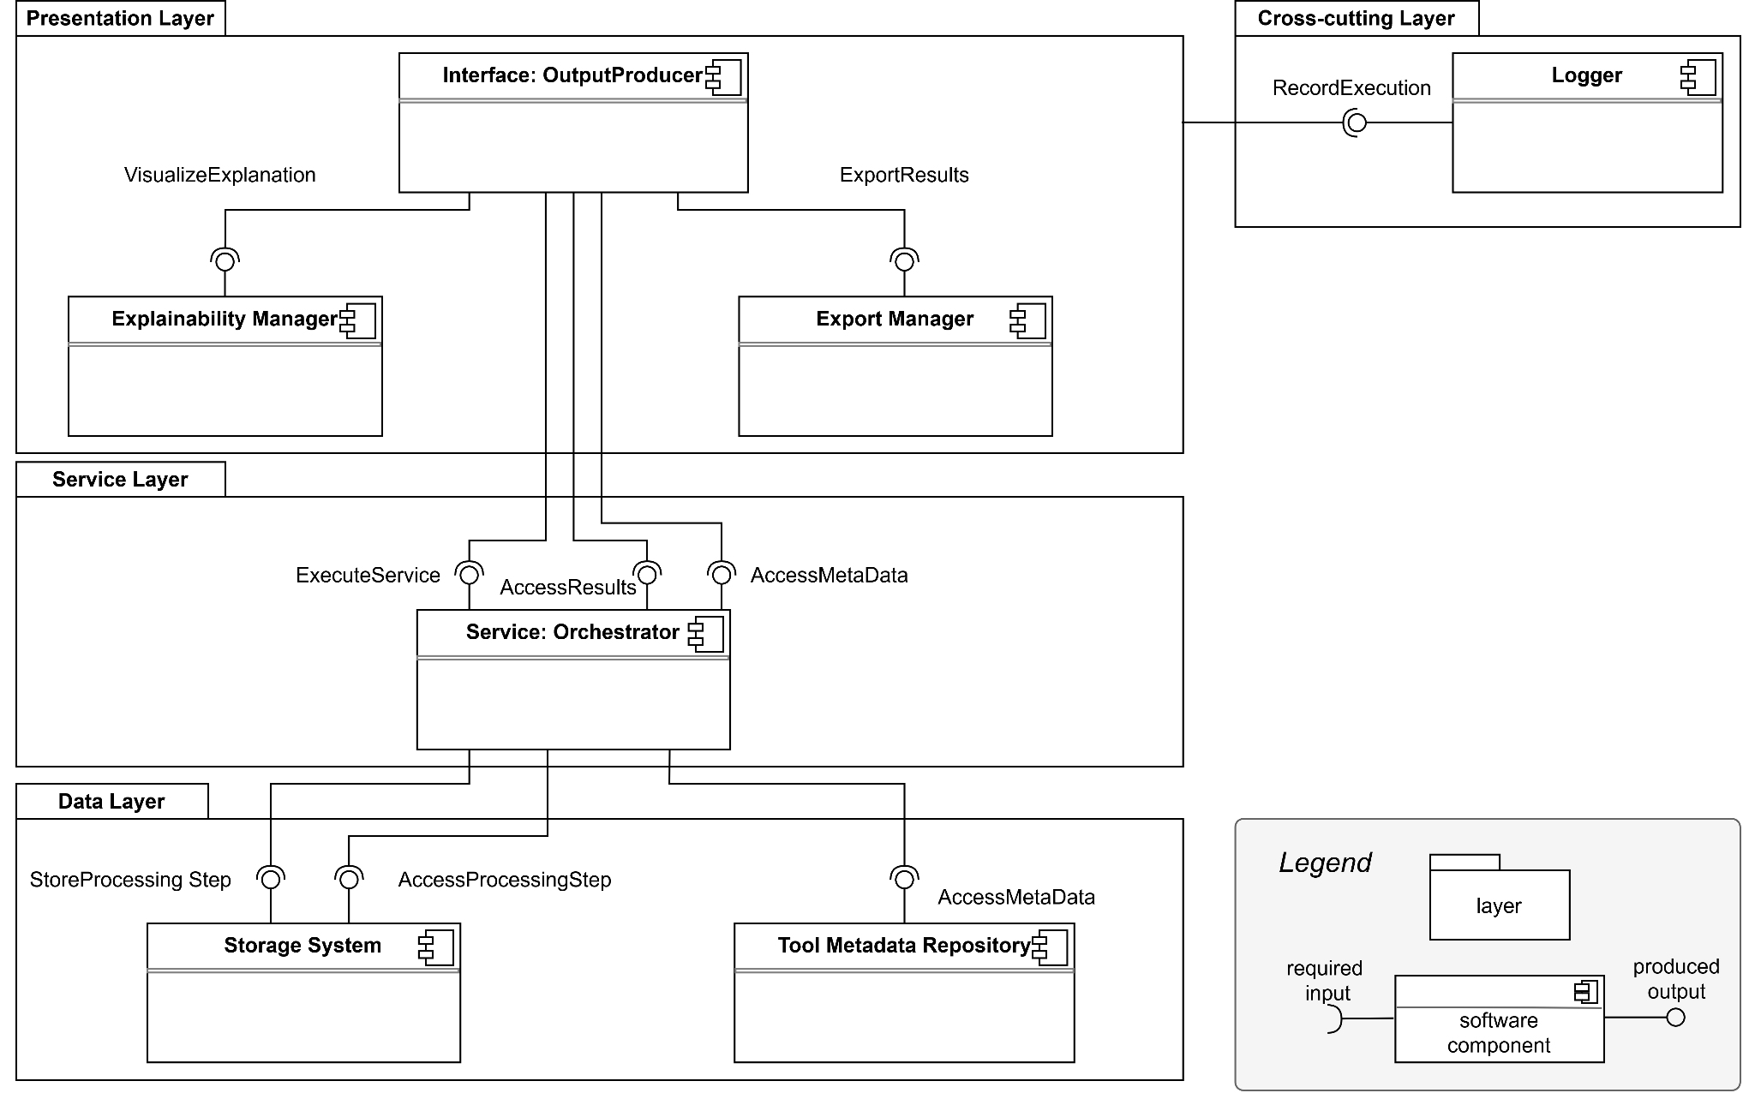
Figure 3. SOA View of AIRERA
Figure 2 illustrates AIRERA’s SOA view. This view emphasizes that AIRERA is not a fixed tool but a composition of interacting services. Implementations may be local, remote, or hybrid, as long as interface contracts are respected.

2.3. Pipe-and-Filter View

📒 A pipe-and-filter view models systems as a sequence of processing elements (filters) connected by data flows (pipes). This view is well suited for reasoning about transformation pipelines, reuse of processing steps, and experimental comparability.

AIRERA models NLP4RE tools as configurable pipelines composed of the following filter types:
- Input Consumer: Reads requirements artifacts and transforms them into a common internal representation.
- Preprocessor: Enriches parsed artifacts with syntactic or semantic information.
- Processor: Performs an RE-relevant NLP task on the preprocessed artifacts.
- Postprocessor: Prepares processor outputs for visualization, interpretation, or further analysis.

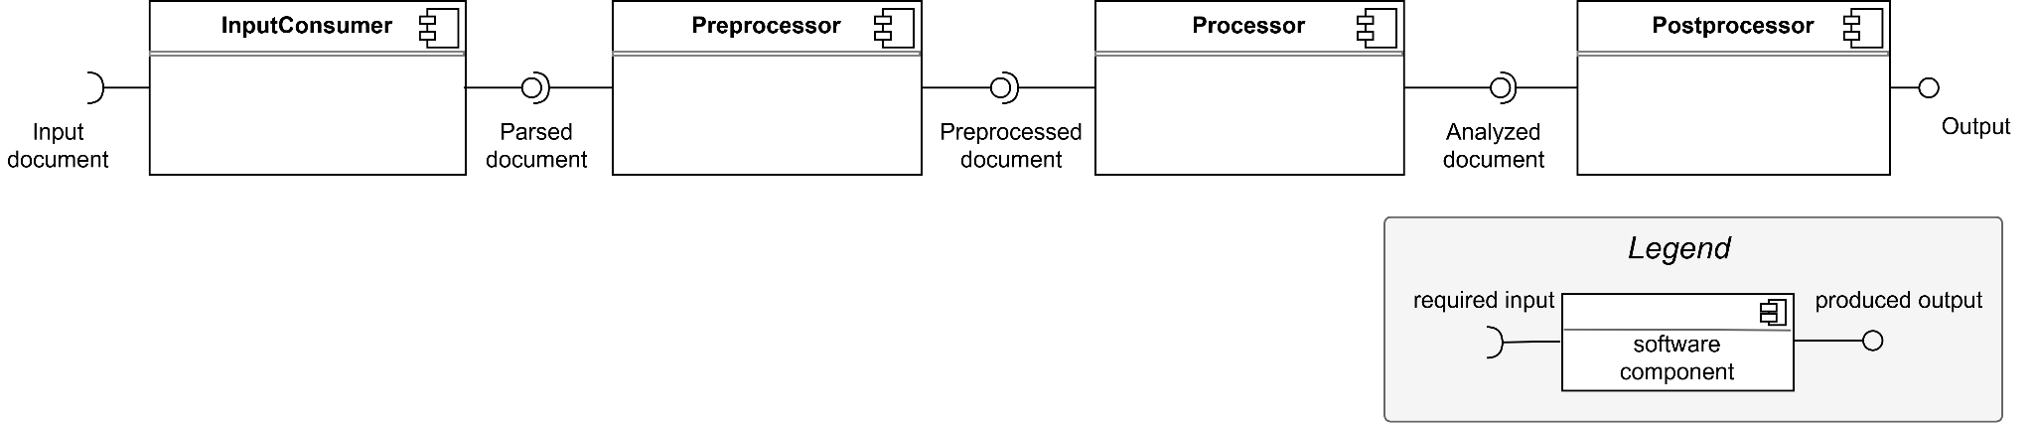
Figure 4. Pipe-and-filter View of AIRERA
Figure 3 illustrates AIRERA’s pipe-and-filter view. Pipes between filters transmit artifacts in standardized formats, enabling individual filters to be replaced or reused without affecting the rest of the pipeline. This structure directly supports benchmarking, ablation studies, and controlled experimentation by allowing alternative processors or preprocessors to be swapped while keeping the remaining pipeline fixed.

3. Conclusions
AIRERA provides a structured, view-based SRA tailored to the recurring needs of NLP4RE tools. By combining layered, service-oriented, and pipe-and-filter perspectives, the architecture offers complementary views on responsibility allocation, runtime interaction, and data processing, supporting modularity, interoperability, comparability, and long-term maintainability.
This document is intended as a basis for expert evaluation and feedback. Practitioner input will be essential to assess the clarity, completeness, and practical usefulness of AIRERA, and to guide its iterative refinement toward a shared architectural foundation for the NLP4RE community.

References
[1] L. Zhao, et al., Natural language processing for requirements engineering: A systematic mapping study, ACM Computing Surveys 54 (2022) Article 55, 1–41. doi:10.1145/3444689.
[2] J. Frattini, et al., Requirements quality research artifacts: Recovery, analysis, and management guideline, Journal of Systems and Software (2024) 112120. doi:10.1016/j.jss.2024.112120.
[3] S. Abualhaija, et al., Replication in requirements engineering: The NLP for RE case, ACM Transactions on Software Engineering and Methodology 33 (2024) Article 151, 33 pages. doi:10.1145/3658669
[4] E. Y. Nakagawa, et al., Consolidating a process for the design, representation, and evaluation of reference architectures, in: 2014 IEEE/IFIP Conference on Software Architecture, 2014, pp. 143–152. doi:10.1109/WICSA.2014.25.
[5] P. Clements, F. Bachmann, L. Bass, D. Garlan, J. Ivers, R. Little, P. Merson, R. Nord, J. Stafford, Documenting software architectures: views and beyond, Addison Wesley, 2010.
[6] L. Garcés, et al., Three decades of software reference architectures: A systematic mapping study, Journal of Systems and Software 179 (2021) 111004. doi:10.1016/j.jss.2021.111004.
[7] Frattini, J., Fischbach, J., & Bauer, A. (2023, September). CiRA: An open-source Python package for automated generation of test case descriptions from natural language requirements. In 2023 IEEE 31st International Requirements Engineering Conference Workshops (REW) (pp. 68-71). IEEE.

